Business Requirements Document (BRD)
Project: AutoPrice AI - European Used Vehicle Price Prediction System

Table of Contents
- Document Version History
- Executive Summary
- Project Overview & Market Context
  - Market Landscape Analysis
  - Problem Statement Deep Dive
  - Project Vision & Strategic Objectives
  - Project Scope (In-Scope / Out-of-Scope)
- Stakeholder Analysis & User Personas
- Solution Overview & Value Proposition
- Detailed Requirements Specification
  - Business & Process Requirements
  - Functional Requirements
  - Non-Functional Requirements
  - Data Requirements
- System Architecture & Technical Design
  - System Context Diagram
  - High-Level System Architecture
  - Price Prediction Engine Components
- Core Processes & Use Cases
  - Price Prediction Request Workflow
  - Data Collection & Model Training Process
  - Detailed Use Case Specifications
- Data Model & Pricing Methodology
- User Interface & Integration Design
- Assumptions, Constraints & Dependencies
- Risk Assessment & Mitigation Strategy
- Appendices
  - Glossary of Terms
  - Supported Vehicle Brands & Attributes
  - EU Emissions Standards Reference

1. Document Version History
Version | Date | Author | Change Description
0.1 | 2023-10-19 | AutoPrice BA Team | Initial Draft
0.5 | 2023-10-23 | AutoPrice BA Team | Added technical specifications
1.0 | 2023-10-26 | AutoPrice Steering Committee | Final approved version

2. Executive Summary
The European used vehicle market represents a complex, fragmented ecosystem valued at over €200 billion annually. Despite its size, pricing remains largely subjective, creating significant inefficiencies for buyers, sellers, and dealers alike. AutoPrice AI addresses this critical market gap by delivering a sophisticated, data-driven price prediction platform specifically engineered for European market dynamics.
This BRD outlines the requirements for an AI-powered vehicle valuation system that combines statistical modeling with Large Language Model (LLM) reasoning to generate accurate, transparent, and regulation-aware price estimates. The system will analyze key vehicle attributes—including mileage, age, brand, model, and crucially, EU emissions compliance data—to provide fair market value predictions tailored to regional markets, starting with Belgium.
The solution bridges the transparency gap in automotive transactions, empowering consumers with confidence, enabling dealers to optimize inventory pricing, and providing marketplaces with enhanced valuation tools. By incorporating environmental regulations and local market trends, AutoPrice AI delivers not just price predictions, but intelligent market insights that reflect the true value determinants in the modern European automotive landscape.
3. Project Overview & Market Context
3.1 Market Landscape Analysis
The European used car market is characterized by several unique factors that differentiate it from global counterparts:
- Regulatory Complexity: Stringent and evolving EU emissions standards (Euro 1-6, transitioning to Euro 7) directly impact vehicle valuation, especially in urban areas with environmental zones (LEZs).
- Regional Fragmentation: Significant price variations exist between Northern and Southern Europe, as well as between countries with different taxation regimes and consumer preferences.
- Brand Concentration: European markets show strong loyalty to both domestic manufacturers (VW, Peugeot, Mercedes) and specific Asian brands (Kia, Toyota) that have established strong market positions.
- Digital Transformation Lag: While online marketplaces exist, most still rely on basic pricing algorithms that fail to capture nuanced regional and regulatory factors, creating pricing anomalies.
3.2 Problem Statement Deep Dive
The current used vehicle pricing ecosystem suffers from multiple systemic issues:
- Pricing Opacity and Inconsistency: A single vehicle can be listed with price variations exceeding 20% across different platforms. Sellers often price based on intuition or outdated "blue book" values, while buyers struggle to identify fair market value.
- Neglect of Regulatory Impact: Environmental regulations are becoming primary value drivers. A Euro 5 diesel vehicle may be nearly worthless in a city implementing a strict Low Emission Zone (LEZ), yet current pricing tools rarely factor this adequately.
- Information Asymmetry: Dealers and professional sellers possess market knowledge that individual buyers lack, leading to potential overpayment. There is no standardized, trusted reference point.
- Dynamic Market Sensitivity: Used car prices are highly sensitive to fuel price fluctuations, new model releases, regulatory announcements, and economic conditions. Static pricing models cannot keep pace.
- Lack of Explanatory Insights: Even when a price is given, the rationale behind it is rarely explained. Buyers and sellers cannot understand why a vehicle is valued a certain way, reducing trust in the valuation.
3.3 Project Vision & Strategic Objectives
Vision: To become the definitive, trusted source of intelligent vehicle valuation for Europe, transforming opaque pricing into transparent, data-driven insights.
Strategic Objective | Key Performance Indicator (KPI) | Target
Achieve Market-Leading Accuracy | Mean Absolute Percentage Error (MAPE) vs actual sale prices | < 8% MAPE
Deliver Regulatory-Aware Valuations | Coverage of major city LEZ rules in price output | 100%
Ensure Rapid Market Responsiveness | Time to reflect major market changes in predictions | < 72 hours
Drive User Adoption | Monthly valuation requests (API + Web) | > 50,000 / month
Establish Partner Ecosystem | Integrated dealerships or marketplaces | 10+ partners (Year 1)

3.4 Project Scope
In-Scope for MVP (Phase 1):
- A cloud-based API and web application for single vehicle price predictions.
- Support for the Belgian market as the primary launch region.
- Coverage of 8 core brands: Mercedes-Benz, BMW, Audi, Volkswagen, Peugeot, Volvo, Ford, Kia.
- Input parameters: Make, Model, Model Year, Mileage, Fuel Type, Transmission, CO₂ Emissions, Euro Standard, Warranty Status.
- Dual prediction engine: Statistical (regression-based) and LLM-based explanatory models.
- Output of a price range (low, fair, high) with confidence interval and key rationale factors.
- A basic historical data ingestion pipeline from public EU market sources.
Out-of-Scope:
- Valuation for new vehicles, classic cars, or commercial trucks.
- Physical vehicle inspection or condition assessment beyond standard parameters.
- Direct integration with vehicle registration databases (GDPR constraints).
- Real-time bidding or auction management functionality.
- Insurance or financing rate calculations.
- Markets outside the European Union in Phase 1.

4. Stakeholder Analysis & User Personas
Stakeholder Group | Primary Influence/Interest | Key Goals & Motivations | Potential Concerns
Individual Private Seller | Getting fair market value, selling quickly. | Avoid underpricing, understand what features add value, set a competitive listing price. | Accuracy of prediction, trust in the tool, ease of use, cost.
Used Car Dealer | Inventory turnover, profit margin maximization. | Price inventory competitively, identify undervalued vehicles at auction, justify prices to customers. | Integration with existing dealer management systems (DMS), bulk valuation capabilities, reliability.
Online Marketplace Platform | User trust, transaction volume, data monetization. | Provide a value-added tool to users, increase listing quality, reduce pricing disputes. | API performance and cost, white-labeling options, data privacy.
Fleet & Leasing Company | Residual value accuracy, asset management. | Accurately forecast end-of-lease values, optimize remarketing strategy. | Model transparency, ability to handle bulk evaluations, audit trails.
Regulatory Bodies (Indirect) | Market transparency, environmental goals. | Encourage cleaner vehicle adoption through transparent pricing of emissions impact. | Accuracy of environmental factor modeling.
AutoPrice Development Team | Building a robust, scalable product. | Clean, well-defined data sources, clear success metrics, modern tech stack. | Data quality issues, scope creep, ambiguous pricing logic.
Primary User Persona: "Independent Dealer"
- Name: Marco van Dijk
- Role: Owner of a small used car dealership in Antwerp.
- Context: Needs to price 5-10 new vehicles per week sourced from auctions and trade-ins. Competes with larger dealers and online platforms.
- Goals: Quickly get accurate prices to sticker cars, explain prices to skeptical buyers, avoid overpaying at auction.
- Frustrations: Current tools are generic, don't understand Belgian market nuances, and can't explain why a price is what it is.
5. Solution Overview & Value Proposition
AutoPrice AI is not a simple price lookup tool; it is an Automotive Market Intelligence Engine. While competitors offer static valuation tables or basic regression models, our core differentiator is the fusion of high-frequency market data with explainable AI reasoning and regulatory intelligence.
The value proposition is articulated across three pillars:
- Unprecedented Accuracy & Relevance: By focusing deeply on the European ecosystem—ingesting local sales data, tracking regional regulations, and understanding brand-specific depreciation curves—we provide the most contextually relevant prices available.
- Transparency & Trust: Our LLM-based "Price Reasoning" module doesn't just output a number; it generates a clear, plain-language summary of the top factors influencing the valuation (e.g., "Price reduced by €1,200 due to Euro 5 diesel non-compliance with upcoming Brussels LEZ expansion").
- Actionable Intelligence for Businesses: For dealers and platforms, we provide APIs and dashboards that turn raw predictions into business insights—identifying pricing trends, undervalued market segments, and the impact of regulatory changes on inventory value.
This positions AutoPrice AI as a critical decision-support system, reducing financial risk and uncertainty in every vehicle transaction.
6. Detailed Requirements Specification
6.1 Business & Process Requirements
ID | Business Requirement Description | Priority | Associated KPI
BR-001 | The system must provide a price prediction for a used vehicle that is within 8% of the actual average transaction price for similar vehicles in the same region. | High | MAPE < 8%
BR-002 | The system must clearly quantify and explain the impact of environmental factors (CO₂, Euro standard) on the predicted price. | High | Regulatory Factor Explanation in 100% of outputs
BR-003 | The system must reduce the time taken by a dealer to research and price a new vehicle addition to their inventory by at least 70%. | High | Dealer pricing time < 5 minutes/vehicle
BR-004 | The system must support both individual consumer queries and high-volume API integrations for business partners. | High | 99.9% API uptime, < 200ms p95 latency
BR-005 | The prediction models must be retrained automatically at least weekly to incorporate the latest market sales data. | Medium | Weekly automated retraining pipeline
6.2 Functional Requirements
Core Prediction Module:
ID | Requirement | Acceptance Criteria
FR-101 | Accept vehicle specs via web form and REST API | JSON fields validated successfully
FR-102 | Validate all input parameters | Descriptive errors for invalid inputs
FR-103 | Generate baseline price using statistical model | Outputs price range + confidence
FR-104 | Generate explanatory pricing factors using LLM | Returns positive/negative factors
FR-105 | Combine statistical and LLM outputs | Unified response returned

Data Management Module:
ID | Requirement | Acceptance Criteria
FR-201 | Ingest daily vehicle listings from EU marketplaces | >95% listings processed
FR-202 | Maintain vehicle specs & emissions reference DB | Covers last 15 years
FR-203 | Track EU Low Emission Zone regulations | All major EU cities covered

Administration & Integration Module:
ID | Requirement | Acceptance Criteria
FR-301 | Admin dashboard for monitoring accuracy & pipelines | Hourly updates
FR-302 | API key management with rate limiting | Keys configurable by tier
FR-303 | Batch prediction API | ≤100 vehicles per request

6.3 Non-Functional Requirements
- Performance:
  - The 95th percentile response time for a single vehicle prediction via API shall be under 200 milliseconds.
  - The batch prediction endpoint shall process 100 vehicles within 15 seconds.
- Scalability: The system shall handle a peak load of 100 prediction requests per second.
- Availability: The public API shall maintain 99.9% uptime.
- Data Freshness: Market data used for predictions shall be no more than 7 days old.
- Security: All API endpoints shall use HTTPS. API keys shall be required for all requests beyond a trivial free tier. Personal data (if any) shall be anonymized and processed in compliance with GDPR.
- Explainability & Audit: Every price prediction must have an associated, storable rationale that can be reviewed for accuracy and bias.
7. System Architecture & Technical Design
7.1 System Context Diagram
7.2 High-Level System Architecture
7.3 Price Prediction Engine Components
- Statistical Model (XGBoost/Gradient Boosting): Trained on historical sales data. Handles numerical features (mileage, age, CO₂) and categorical features (brand, fuel type) to produce a baseline price distribution. Provides high accuracy and speed.
- LLM Reasoning Engine (Fine-tuned Model): Takes the vehicle attributes and the statistical model's output as input. Its role is to:
  - Access a knowledge base (stored in a Vector Database) containing regulatory texts, market reports, and brand reliability insights.
  - Generate a human-readable summary of key valuation factors.
  - Identify edge cases the statistical model might miss (e.g., a specific model with a known, costly common fault).
- Ensemble Layer: Combines the confidence scores and outputs from both models to produce a final, authoritative prediction and explanation.
8. Core Processes & Use Cases
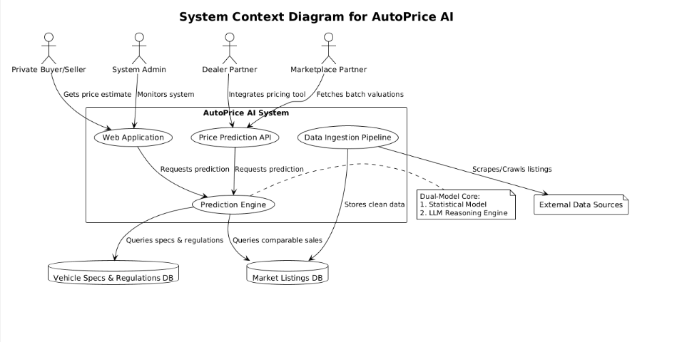
8.1 Price Prediction Request Workflow
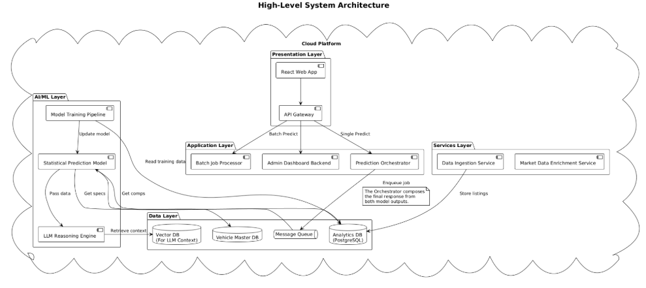
8.2 Data Collection & Model Training Process
A separate, automated pipeline handles the continuous improvement of the system:
- Data Collection: Daily scraping of major marketplace listings (price, specs, listing duration).
- Data Enrichment: Matching listings to the master vehicle database to fill in missing attributes (e.g., CO₂, Euro standard).
- Ground Truth Creation: Identifying "sold" prices (via listing removal or price change heuristics) to create training data.
- Model Retraining: Weekly retraining of the Statistical Model on the latest data. Periodic fine-tuning of the LLM on new regulatory and market news.
- Model Validation & Deployment: Automated testing against a hold-out dataset; if performance meets criteria (MAPE < threshold), the new model is deployed seamlessly.
8.3 Detailed Use Case Specifications
Use Case ID: UC-001
Use Case Name: Get Price Estimate for a Private Sale
Primary Actor: Private Seller
Precondition: Seller has the vehicle's basic specifications and VIN (optional).
Main Success Scenario:
- Seller navigates to the AutoPrice AI website.
- Seller selects make (e.g., Volkswagen), model (e.g., Golf), and year (e.g., 2018) from dropdowns.
- Seller inputs mileage (e.g., 85,000 km), fuel type (Diesel), transmission (Automatic).
- Seller inputs the CO₂ value (from registration) and selects Euro Standard (Euro 6).
- Seller indicates if any warranty remains (Yes/No).
- Seller clicks "Estimate Price".
- System displays:
  - Price Range: €17,200 - €18,500 (Fair Price: €17,850)
  - Confidence: High (92%)
  - Key Factors:
    - (+) Low mileage for age adds approximately €700.
    - (+) Euro 6 compliant, no LEZ restrictions.
    - (-) Diesel fuel type reduces value by ~€1,000 compared to equivalent petrol.
    - (+) Remaining manufacturer warranty adds ~€400.
- Seller uses this information to set their listing price.
Postcondition: Seller has a data-driven price estimate and understands its components.
Alternate Flows: If the vehicle has rare specifications, system may return a "Low Confidence" flag and suggest getting a professional appraisal.
9. Data Model & Pricing Methodology
Core Vehicle Entity Schema:
Attribute | Type | Description | Source
vehicle_id | UUID | Unique identifier | System-generated
make | String | Manufacturer (e.g., "Volvo") | Input / Master DB
model | String | Model name (e.g., "XC60") | Input / Master DB
model_year | Integer | Year of manufacture | Input
trim | String | Trim level (optional) | Input / Master DB
mileage_km | Integer | Odometer reading | Input
fuel_type | Enum | Petrol, Diesel, Hybrid, Electric, PHEV | Input / Master DB
transmission | Enum | Manual, Automatic | Input / Master DB
co2_emissions_gkm | Integer | CO₂ emissions in g/km | Input / Master DB
euro_standard | Enum | Euro 3, 4, 5, 6, 6d, 6e | Input / Master DB
has_warranty | Boolean | Factory or extended warranty active | Input
Prediction Output Schema:
json
{
"request_id": "req_abc123",
"vehicle_description": "2018 Volkswagen Golf 2.0 TDI DSG",
"prediction": {
"price_low_eur": 17200,
"price_fair_eur": 17850,
"price_high_eur": 18500,
"confidence_score": 0.92,
"currency": "EUR",
"market_region": "BE-Flanders"
},
"explanation": {
"summary": "Fair market value estimated at €17,850. Price is positively influenced by low mileage and warranty, but negatively impacted by diesel fuel type in the current market.",
"factors": [
{"impact": "positive", "factor": "mileage_below_average", "estimated_effect_eur": 700},
{"impact": "negative", "factor": "fuel_type_diesel", "estimated_effect_eur": -1000},
{"impact": "positive", "factor": "euro_6_compliant", "estimated_effect_eur": 1500},
{"impact": "positive", "factor": "has_warranty", "estimated_effect_eur": 400}
]
},
"disclaimer": "Estimate based on market data up to 2023-10-25. Actual sale price may vary."
}
Pricing Methodology: The statistical model uses a gradient boosting algorithm trained on features engineered from the core attributes, including:
- Age Depreciation: Non-linear curve based on brand and model.
- Mileage Penalty: Per-km depreciation that increases after certain thresholds.
- Emission Compliance Score: A calculated penalty/bonus based on Euro standard and local LEZ rules.
- Regional Market Multiplier: Adjustment factor for specific countries/regions within the EU.
10. User Interface & Integration Design
Web Interface Principles:
- Progressive Disclosure: Start with simple inputs (Make, Model, Year), reveal advanced fields (CO₂, Euro Standard) optionally.
- Visual Feedback: Show price range on a visual slider. Display key positive/negative factors as clear, color-coded badges.
- Transparency: Always show the data date and confidence level prominently.
API Design:
- RESTful endpoints: POST /v1/predict for single, POST /v1/predict/batch for multiple.
- Response Formats: JSON only.
- Rate Limiting: Communicated via HTTP headers (X-RateLimit-Limit, X-RateLimit-Remaining).
- Error Handling: Standard HTTP codes with descriptive messages in the response body.
Partner Integration: Offer SDKs in popular languages (Python, JavaScript) and a plugin/widget for marketplace websites that can be embedded to show "AutoPrice AI Estimated Value" on listing pages.
11. Assumptions, Constraints & Dependencies
- Assumptions:
  - Sufficient volume of public listing data is available for model training.
  - Vehicle specification data (CO₂, Euro standard) can be reliably sourced or derived from model/year/fuel type.
  - Users will provide accurate information; the system is not responsible for valuations based on incorrect inputs.
  - The regulatory environment (LEZ rules) changes at a predictable pace with public announcements.
- Constraints:
  - Cannot access actual transaction prices (only listing prices) due to data privacy.
  - Initial model accuracy will be lower for rare vehicle configurations.
  - GDPR compliance limits the ability to store or process personal data from listings.
- Dependencies:
  - Availability and stability of third-party data sources (marketplace websites, regulatory databases).
  - Cost and performance of underlying LLM APIs (e.g., OpenAI GPT-4, Anthropic Claude).
  - Cloud infrastructure provider (AWS, Azure, GCP) for scalable deployment.
12. Risk Assessment & Mitigation Strategy
Risk | Probability | Impact | Mitigation Strategy
Data Quality & Availability | Medium | High | Implement multiple data source fallbacks; develop sophisticated data imputation and validation logic; manually curate specs for key models.
Model Inaccuracy / Bias | Medium | High | Implement rigorous back-testing against hold-out data; establish a human-in-the-loop review for edge cases; regularly audit model for demographic or geographic bias.
Regulatory Change | High | Medium | Build a flexible rules engine separate from the core ML model to apply regulatory adjustments; subscribe to official EU and municipal feeds.
Competitor Response | High | Medium | Focus on defensible differentiation (explainability, regulatory depth) rather than just price; pursue strategic partnerships with marketplaces early.
LLM Cost & Latency | Medium | Medium | Implement caching for common vehicle profiles; use a smaller, fine-tuned model for common cases; fall back to template-based explanations if LLM is unavailable.
Market Volatility (e.g., chip shortage) | High | High | Increase model retraining frequency during volatile periods; incorporate macroeconomic indicators (fuel prices, new car delivery times) as model features.
13. Appendices
13.1 Glossary of Terms
- LEZ (Low Emission Zone): A defined area where access is restricted for vehicles that do not meet certain emission standards.
- Euro Standard: European emission standards defining the acceptable limits for exhaust emissions of new vehicles.
- MAPE (Mean Absolute Percentage Error): A measure of prediction accuracy, calculated as the average absolute percent error for each prediction.
- Residual Value: The estimated value of an asset at the end of its lease or useful life.
13.2 Supported Vehicle Brands & Attributes (MVP)
- Brands: Mercedes-Benz, BMW, Audi, Volkswagen, Peugeot, Volvo, Ford, Kia.
- Fuel Types: Petrol, Diesel, Hybrid, Plug-in Hybrid (PHEV), Electric (BEV).
- Transmission: Manual, Automatic.
- Euro Standards: Euro 4, Euro 5, Euro 6, Euro 6d-TEMP, Euro 6d.
13.3 EU Emissions Standards Reference
A brief table outlining key Euro standards relevant to used car valuation:
Standard | Applicable From | Key Impact | Typical LEZ Restriction
Euro 5 | 2009/2011 | Particulate limits for diesels | Banned in many city centers
Euro 6 | 2014/2015 | Reduced NOx for diesels | Generally permitted
Euro 6d | 2020/2021 | Real Driving Emissions (RDE) test | Fully compliant

Document Approval
Role | Name | Signature | Date
Product Sponsor
Lead Business Analyst
Lead Architect
Project Manager

